**Practical name** – demonstrate to INSERT, UPDATE, and DELETE records in table

**Student name:**– Gayatri Ishwar Kale **Roll no:**– 54

Div:-A Batch:-2

USE hospital;

UPDATE patients SET first_name = 'cheater' WHERE first_name = 'mrunal';

DELETE FROM patients WHERE patient_id = 9;

SELECT * FROM patients;

OUTPUT –

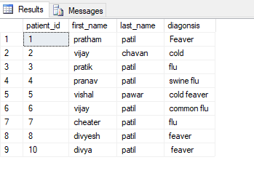

DELETE FROM patients WHERE patient_id = 9;

OUTPUT –

